HANOI UNIVERSITY OF SCIENCE AND TECHNOLOGY

**School of Economics and Management**

­­­­­

**GROUP REPORT**

**Subject: Business Forecasting – EM4810E**

**Topic: The status of Technology and Innovation of Vietnamese Firms & Its impact on Firms Performance**

**Students:** Nguyen Ngoc Van Khanh 20213066

Tong Ngoc Huyen 20213065

Nguyen Do Quyen 20213093

Bui Anh Van 20213106

**Class:** Business Analytics K66

**Class code:** 149149

**Lecturer:** Ha Thi Thu Trang

***Hanoi, May 2024***

TABLE OF CONTENTS

*EXECUTIVE SUMMARY* 2

*A.* *VISUALIZATION* 3

I. Characteristics of Vietnamese firms surveyed 3

II. Overview of the status of Innovation and Technology of Vietnamese firms 4

1. Status of Innovation and Technology of Vietnamese firms between 2015 and 2023 4

2. Status of Innovation and Technology of Vietnamese sectors between 2015 and 2023 5

3. Status of innovation and technology of Vietnamese firms in 2023 6

*B.* *Regression model* 8

I. Target 9

II. Variables definition 9

III. Relationship description 10

IV. Regression model 15

1. Full model 15

2. Shortened model 16

3. Testing assumptions 16

4. Using AIC method 17

*C.* *Conclusion* …………………………………………………………………..18

# 

# EXECUTIVE SUMMARY

Nowadays, Technology and Innovation play a crucial role in enhancing the firm’s performance. The use of information and communication technologies (ICT) in business transactions, ICT, such as the Internet, are important tools all firms because they provide even the smallest of enterprises with the ability to reach national and international markets at lower cost. Therefore, understanding the status of Technology and Innovation of Vietnamese firms can help them gain insight into the current situation of these factors as well as its impact to firms’ performance.

By using the data gathered by the World Bank Enterprise Surveys (WBES), which was implemented in Viet Nam between April 2023 and November 2023, our group also utilized the support from several tools such as R-studio, Excel…we can see that there was a downward trajectory in the number of establishments introducing new products/services as well as the investment in R&D in 2023. Additionally, manufacturing sectors have experienced several obstacles in Technology and Innovation while retail services and other services have witnessed an upward trend in digital transformation. In this report, our group will provide further explanation for these trends.

Besides, through constructing multiple linear regression model, it shows that obtaining international quality certifications and introducing new products/services are two factors that influence most on the total annual sales of the companies. These indicators may support companies creating more efficient or effective operations and improve employee’s motivation, awareness, and morale. They also provide a sign of high quality that may help reduce waste and increase productivity.

As a result, Vietnamese establishments are encouraged to promote having international quality certifications as well as foster to introduce new products/services. From that, the companies can adapt to the changing in consumer preferences and achieve competitive advantages.

1. **VISUALIZATION**
2. **Characteristics of Vietnamese firms surveyed**
3. **Sector**

|  |  |
| --- | --- |
|  | A total of 1,028 companies were surveyed, with a majority of them being manufacturing companies in Vietnam. |

Appendix I.1.1: Number of firms by sectors

1. **Size**

|  |  |
| --- | --- |
|  | With a total of 1,028 Vietnamese firms were surveyed, observing that the size in a diverse range from Small (5-19 workers) to Large (>100 workers). Therefore, the information obtained is objective and useful. |

Appendix I.1.2: Size of Vietnamese firms

1. **Age**

|  |  |
| --- | --- |
|  | Firms that have been operating for 11-20 years account for 46%, while startups represent a significant 28%, indicating that Vietnam is in a phase of promoting innovation and creativity in companies across various sectors. |

Appendix I.1.3: Age Distribution of Vietnamese firms

1. **Overview of the status of Innovation and Technology of Vietnamese firms**
2. **Status of Innovation and Technology of Vietnamese firms between 2015 and 2023**

Appendix I.1.1: Status of Innovation and Technology of Vietnamese firms 2015 and 2023

Most of the surveyed companies have their **own websites and have been continuously growing from 2015 to 2023.** This is a good sign for promoting the use of e-commerce in recent years, which has brought a breakthrough in technology in Vietnam. According to the Vietnam Innovation & Tech Investment Report 2023, Vietnam's internet user base has skyrocketed, reaching over 94%. This surge in internet penetration makes having a website crucial for businesses to reach customers and showcase their offerings.

The wave of companies using technology licensed from foreign-owned companies has been growing strongly in Vietnam, increasing from 75 to 106 over the past 8 years.

In addition to the focus on technology development factors such as investing in websites, using advanced technologies from abroad, the trend of the number of companies in Vietnam in 2023 is focused on investment in innovation and creativity, which has significantly decreased compared to 2018. Specifically:

* In the past 3 years, the number of companies that introduced new or significantly improved products or services has decreased by nearly one-third, from 304 to 114.
* Furthermore, in 2023, the number of companies investing in R&D has decreased by 50% compared to 2018, as well as in the aspect of changing and improving products to meet the current market demands.

1. **Status of Innovation and Technology of Vietnamese sectors between 2015 and 2023**

Appendix II.1.2: Status of Innovation and Technology of Vietnamese by Sectors between

2015 and 2023

In the years 2015 and 2023, companies in the manufacturing sector continued to maintain a high percentage of the use of technology and innovation in the production process. However, by 2023, other service industries and retailers are increasingly adopting technology and innovation.

* 1. **Manufacturing**

*Appendix II.2.1: Manufacturing*

In 2023, the number of companies in the manufacturing sector investing in developing new products, new processes, and R&D has decreased significantly compared to 2015. Combined with the age distribution factor, over 45% of companies have been in operation for 10-20 years, and nearly 25% of companies have an age range of 21-30. This indicates that the process of promoting innovation and creativity in processes and products will face difficulties because these companies already have a solid foundation to sustain their operations over a long period of time.

* 1. **Retail Services and Other Services**

|  |  |
| --- | --- |
|  |  |

Appendix II.2.2: Retail Services  Appendix II.2.3: Other Services

However, companies in the retail and other service sectors are gradually undergoing a strong digital transformation, establishing their own websites and acquiring technology licenses from foreign companies since 2023. This is a positive sign for digital transformation in these sectors.

1. **Status of innovation and technology of Vietnamese firms in 2023**
   1. **Sectors**

Appendix II.3.1: Status of Innovation and Technology of different Industries

In 2023, companies in the manufacturing, retail services, and other services sectors are focusing on intensifying the establishment of their own websites.

In the manufacturing sector, companies are putting a strong emphasis on achieving international product quality certifications and utilizing advanced software and machinery from abroad. Especially, manufacturing companies are investing in developing new products, new processes, and adapting existing products to meet the current market demands. They are particularly investing in R&D within their companies.

* 1. **Percent of firms having its own website 2023**

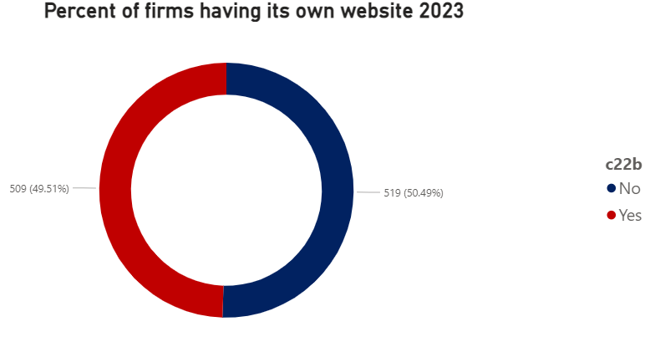

Appendix II.3.2: Percent of firms having its own website 2023

* 1. **Percent of firms that introduced new products/ services**

Appendix II.3.3: Percent of firms that introduced new products/ services 2023

However, nearly 90% of companies are not launching new products or services in 2023. The main reason is that the economy is declining, affecting the profitability of companies due to the impact of the COVID-19 pandemic. Therefore, the strategy of companies is strongly focused on digital transformation and revenue recovery, rather than pushing for the launch of new products, services, or investing in R&D.

* 1. **Relationship between age firms and process innovation in 2023**

The data shows that there are over 600 companies with an operating time ranging from 13 to 32 years that are implementing process innovation, which is nearly double the number of companies with an operating time of 2 to 12 years (in the startup phase). The longer-established companies need to carry out service and product innovation processes in order to meet market demands and gain market share.

Appendix II.3.4: Age Firms and Process Innovation

1. **Regression model**
2. **Target**

By using data collected by Vietnamese Enterprise Surveys, we conduct regression model to estimate the impact of Innovation and Technology to Firms performance in 2023. Moreover, through this model, individuals can identify which factors of Innovation and Technology have the most influence on the total annual sales of the company. From that, the enterprise can implement suitable strategies related to Innovation and Technology to improve the annual sales.

1. **Variables definition**

Dependent variable:

* d2_log: logarithm of total annual sales of firms in 2023

Independent variables:

* b8: whether the enterprise have an internationally-recognized quality certification or not (1: Yes, 2: No)
* e6: whether the enterprise use technology from a foreign-owned company or not (1: Yes, 2: No)
* c22b: whether the establishment has its own website or not (1: Yes, 2: No)
* h1: are there any new products/services introduced over last 3 years (1: Yes, 2: No)
* f1: the capacity utilization (%) of this establishment in last FY
* h5: whether the establishment introduced new/significantly improved process during las 3 years (1: Yes, 2: No)
* h8: during the last fiscal year, establishment spent on R&D or not (1: Yes, 2: No)
* c36: whether establishment apply to obtain fixed broadband internet connection over the last 2 years (1: Yes, 2: No)
* c39: is there any internet disruptions in last FY (1: Yes, 2: No)
* l4b: number of permanent, full-time low skilled production worker
* l1: number of permanent, full-time employees at end of last FY
* a6a: sampling size - 1: Small (5 to 19 employees), 2: Medium (20 to 99 employees), 3: Large (100 or more employees).
* a2: sampling region (1: Northern Central region, the Central Coast, Central Highlands; 2: Red River Delta; 3: Northern Midlands and Mountains; 4: Southeast; 5: Mekong River Delta)

1. **Relationship description** A graph with a line graph

   Description automatically generated with medium confidence

Appendix III.1: Distribution of total annual sales

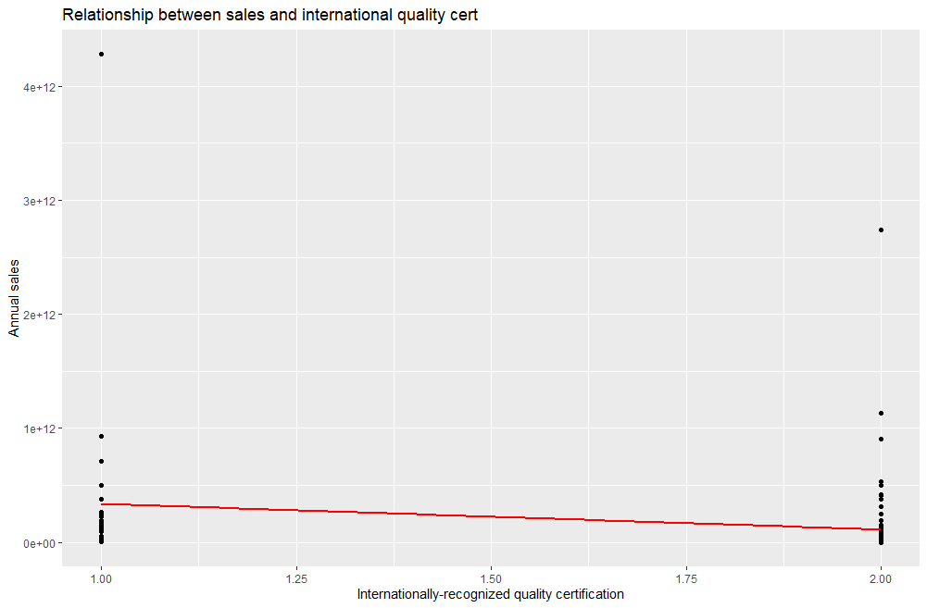The histogram shows that the distribution of the total annual sales of firms in 2023 is highly skewed to the right. Most revenue values ​​are concentrated in small values, while there are some very large revenue values ​​(outliers) located far to the right, which are not too common.Additionally, the total annual sales of Vietnames enterprises are mainly below 500,000B VND.

Appendix III.2: Relationship between sales and international-recognized quality certifications

Chart III.2 shows that there is a positive relationship between the ownership of internationally-recognized quality certifications and total annual sales. If the establishments have an internationally-recognized quality certifications, the total annual revenue is higher than the firms that do not have this kind of certification.

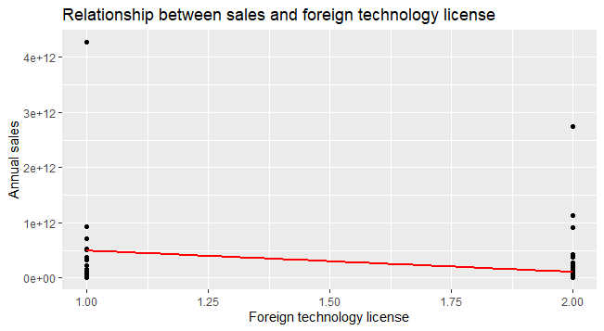Therefore, the international-recognized quality certifications play a crucial role in enhancing the trust of customers about the products/services provided, thus contributing to the revenue growth of companies.

Appendix III.3: Relationship between sales and foreign technology license

Using technology from a foreign-owned company shows a significant positive trend with the total annual revenue of companies. The establishments use technology from a foreign-owned company, the total annual sales also increase.

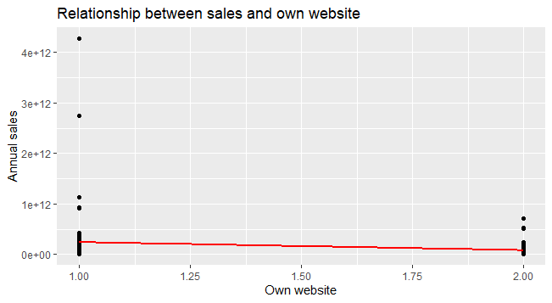 Foreign-owned companies often provide cutting-edge technology that can significantly enhance productivity, efficiency, and innovation within an enterprise. By leveraging these advanced tools and solutions, companies can improve their operational capabilities and product offerings, leading to higher sales.

Appendix III.4: Relationship between sales and own website

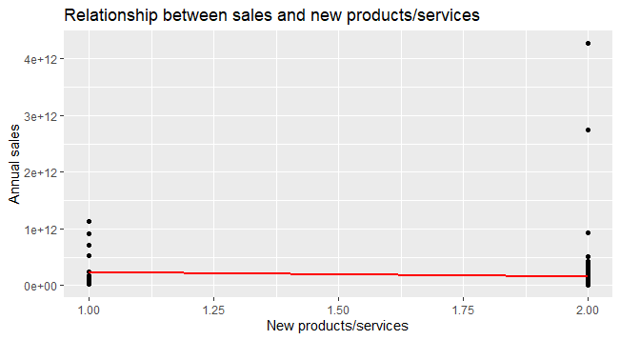There seems to be a positive relationship between sales and the ownership website of establishments. If a company has its own website, this can help the business enhance customer experience, leading the sales growth.

Appendix III.5: Relationship between sales and new products/services

The introduction of new products/services has a slightly positive trend with total annual sales. Whether companies launch new products/services or not does not have a significant impact on the total annual sales of businesses.

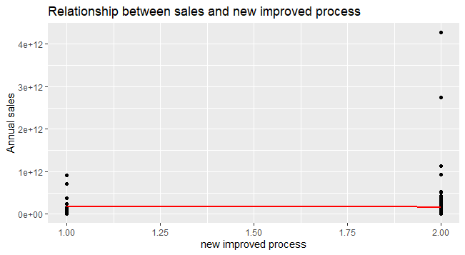Besides, several establishments which do not have new products/services introduced over the last 3 years generate higher total annual sales than the enterprises which introduce new products/services.

Appendix III.6: Relationship between sales and new improved process

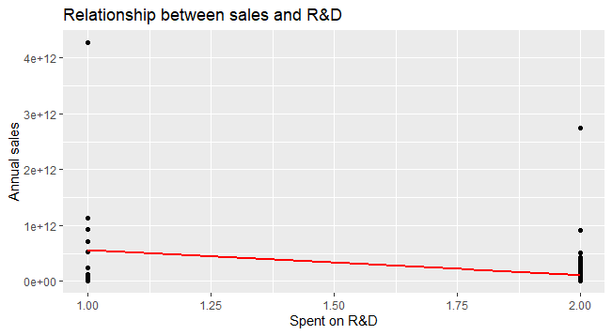There is a weak relationship between sales and the new/significantly improved process introduced during the last 3 years. The new/significantly improved process does not affect the revenue earned by establishments.

Appendix III.7: Relationship between sales and R&D

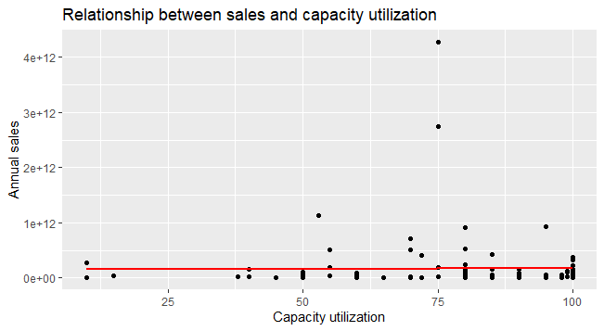The relationship between sales and investment in R&D shows a positive trend. Companies which spend on R&D activities can improve the products/services to adapt the demand of customers. Hence, the enterprises’ sales tend to rise.

Appendix III.8: Relationship between sales and capacity utilization

It illustrates that capacity utilization does not significantly impact the total annual sales of companies. However, when capacity utilization increases, the total annual revenue of businesses improves. With capacity utilization is 75%, there are companies earning the highest sales.

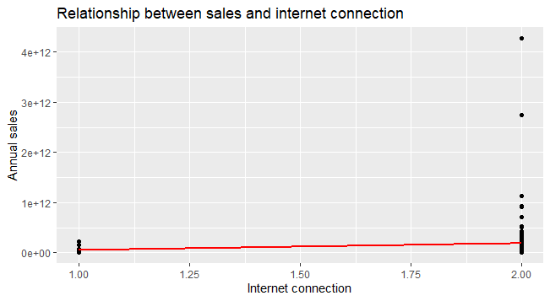

Appendix III.9: Relationship between sales and fixed broadband Internet connection

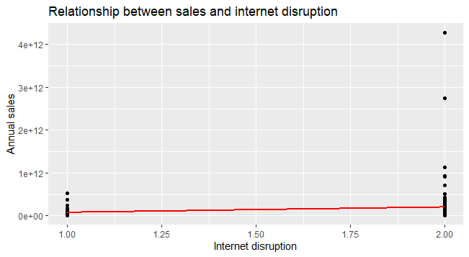There is a negative relationship between sales and using fixed broadband Internet connection*.* Establishments invest in fixed broadband Internet connection, but the total annual sales do not rise. This phenomenon may be due to the increasing use of mobile broadband. With the development of mobile and flexible internet connections, customers tend to shift away from fixed broadband services.

Appendix III.10: Relationship between sales and Internet disruptions

Total annual sales have a negative trend with Internet disruptions. If establishments take place of Internet disruptions, the total annual sales are likely to decrease. Therefore, Vietnamese companies should reduce the likelihood to take place Internet disruptions to increase the customer experience.

Appendix III.11: Correlation matrix 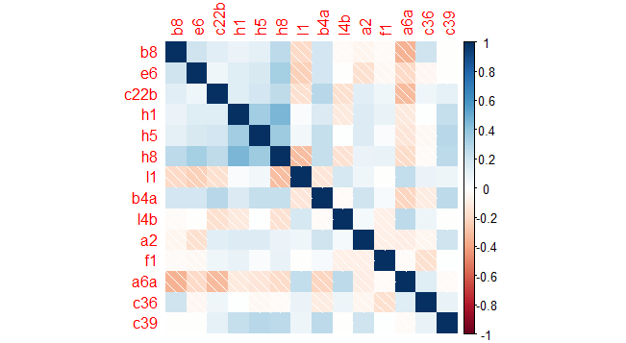

* The correlation coefficients are low (below 0.7)

→ There is no multicollinearity phenomenon between independent variables.

1. **Regression model**
2. **Full model**

|  |  |  |  |  |
| --- | --- | --- | --- | --- |
|  | **Estimate** | **Std.Error** | **T value** | **P value** |
| **(Intercept)** | 24.439394 | 1.4994922 | 16.298 | <2e-16 |
| **b8** | -0.8789934 | 0.3251435 | -2.703 | 0.008030 |
| **e6** | -0.7893195 | 0.3623397 | -2.178 | 0.031657 |
| **c22b** | -0.185669 | 0.2587461 | -0.178 | 0.474645 |
| **h1** | -1.1048736 | 0.3735220 | -2.958 | 0.003841 |
| **l4b** | 0.0030686 | 0.0011860 | 2.587 | 0.011070 |
| **l1** | 0.0006254 | 0.0001990 | 3.143 | 0.002186 |
| **h8** | 0.4572062 | 0.4690647 | 0.975 | 0.331983 |
| **a6a** | 0.6804501 | 0.1996768 | 3.408 | 0.000936 |
| **f1** | 0.0133116 | 0.0055266 | 2.409 | 0.017789 |
| **h5** | 0.0305266 | 0.3804878 | 0.080 | 0.936210 |
| **a2** | 0.1358977 | 0.10236710 | 1.324 | 0.188559 |
| **a4a** | -0.0653203 | 0.1002593 | -0.652 | 0.516166 |
| **c36** | 0.6294876 | 0.3552179 | 1.772 | 0.079332 |
| **c39** | 0.0862656 | 0.2830849 | 0.305 | 0.761184 |

Appendix IV.1: Results of regression model

* P-value <0.05 and |t-value| > 2.1788 with 95% of confidence interval.

→ b8, e6, h1, l4b, l1, a6a, f1 have effect on the dependent variable (d2)

* Adjusted R-squared: 49.02%, Multiple R-squared: 55.12%.

→ About 49.02% of the variation of the dependent variable is explained by the independent variables in the regression model.

1. **Shortened model**

|  |  |  |  |  |
| --- | --- | --- | --- | --- |
|  | **Estimate** | **Std.Error** | **T value** | **P value** |
| **(Intercept)** | 24.7389161 | 1.3279532 | 18.629 | <2e-16 |
| **b8** | -0.9526742 | 0.3141190 | -3.033 | 0.003046 |
| **e6** | -0.8723025 | 0.3509467 | -2.486 | 0.014497 |
| **c22b** | -0.1693801 | 0.2530494 | -0.669 | 0.504724 |
| **h1** | -1.0296254 | 0.3632275 | -2.835 | 0.005494 |
| **l4b** | 0.0032275 | 0.0011709 | 2.756 | 0.006882 |
| **l1** | 0.0006342 | 0.0001954 | 3.246 | 0.001566 |
| **h8** | 0.5393301 | 0.4571779 | 1.180 | 0.240763 |
| **a6a** | 0.6850893 | 0.1899830 | 3.606 | 0.000476 |
| **f1** | 0.0124669 | 0.0054464 | 2.289 | 0.024059 |
| **c36** | 0.6214416 | 0.3475068 | 1.788 | 0.076587 |
| **c39** | 0.1191799 | 0.2720187 | 0.438 | 0.662183 |

Appendix IV.2: Results of shortened regression model

* Adjusted R-squared: 49.43%, Multiple R-squared: 54.19%.

→ About 49.43% of the variation of the dependent variable is explained by the independent variables in the regression model.

Model:

**d2_log** = 24.739- 0.953* b8 - 0.872* e6 - 0.169* c22b – 1.03* h1 + 0.003* l4b + 0.0006* l1 + 0.539* h8 + 0.685* a6a + 0.012* f1 + 0.62* c36 + 0.119*c39

1. **Testing assumptions**
   1. **Normal distribution**

H0: Residuals follow normal distribution.

H1: Residuals do not follow normal distribution.

* P-value = 0.0847 >0.05 → Not enough evidence to reject H0. Therefore, residuals follow normal distribution.
  1. **Assumption 1**

H0: mean(res) = 0

H1: mean(res) ≠ 0

* P-value = 1 > 0.05 → Not enough evidence to reject H0. Therefore, mean(residuals) = 0 → Assumption 1 satisfies.
  1. **Assumption 2**

H0: Variance of residuals is constant.

H1: Variance of residuals is non-constant.

* P-value = 0.7696 > 0.05 → Not enough evidence to reject H0. Therefore, variance of residuals is constant → Assumption 2 satisfies.
  1. **Assumption 3**

H0: There is no autocorrelation in residuals.

H1: There is autocorrelation in residuals.

* P-value = 0.396 > 0.05 → Not enough evidence to reject H0. Therefore, there is no autocorrelation in residuals → Assumption 3 satisfies.

1. **Using AIC method**

|  |  |  |  |  |
| --- | --- | --- | --- | --- |
|  | **Estimate** | **Std.Error** | **T value** | **P value** |
| **(Intercept)** | 24.9580670 | 1.2436537 | 20.068 | <2e-16 |
| **b8** | -0.8826530 | 0.3061677 | -2.883 | 0.00475 |
| **e6** | -0.7737608 | 0.3386661 | -2.285 | 0.02426 |
| **h1** | -0.8144581 | 0.3209901 | -2.537 | 0.01258 |
| **l4b** | 0.0031734 | 0.0011598 | 2.736 | 0.00726 |
| **l1** | 0.0005907 | 0.0001861 | 3.174 | 0.00196 |
| **a6a** | 0.7247379 | 0.1816837 | 3.989 | 0.00012 |
| **f1** | 0.0127067 | 0.0054026 | 2.352 | 0.02047 |
| **c36** | 0.5960082 | 0.3408986 | 1.748 | 0.08322 |

Appendix IV.3: Results of AIC regression model

Model:

**d2_log** = 24.958- 0.882* b8 - 0.773* e6 – 0.814* h1 + 0.003* l4b + 0.0005* l1 + 0.724* a6a + 0.012* f1 + 0.596* c36

* Adjusted R-squared: 49.84%, Multiple R-squared: 53.27%.

→ About 49.84% of the variation of the dependent variable is explained by the independent variables in the regression model.

* -0.882: if establishments have an intertionally-recognized quality certifications, the logarithm of total annual sales increases by 0.882.
* -0.773: if companies use technology licensed from a foreign-owned company, the logarithm of total annual sales increases by 0.773.
* -0.814: if establishments introduce new products/services over last 3 years, there will be a rise by 0.841 in the logarithm total annual sales.
* 0.003: an increase by a person in the number of permanent, full-time low-skilled production workers, the logarithm of total annual sales rises by 0.003.
* 0.005: if the number of permanent, full-time employees at end of last FY increases by 1 person, the logarithm of total annual sales rises by 0.0005.
* 0.724: the larger the companies are, the higher revenue earned by the companies.
* 0.012: if establishments increase the capacity ultilization by 1%, the logarithm of total annual revenue increases by 0.012.
* 0.596: if companies do not obtain fixed broadband Internet connection, the logarithm of total annual revenue increases by 0.596.

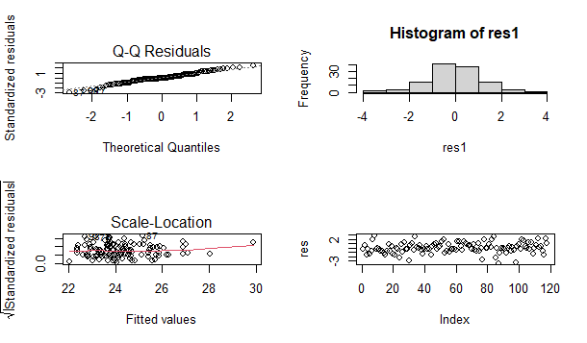Appendix IV.4: Result of assumptions

* Normal distribution: p-value = 0.08768 >0.05 → Residuals follow normal distribution.
* Assumption 1: p-value = 1 >0.05 → Mean(residuals) = 0.
* Assumption 2: p-value = 0.6062 >0.05 → Variance of residuals is constant.
* Assumption 3: p-value = 0.366 >0.05 → There is no autocorrelation in residuals.

1. **Conclusion**

Vietnamese firms have made progress in adopting technology and innovation, with companies having their own websites and utilizing technology licensed from foreign-owned firms.

However, investment in innovation and research and development has declined, leading to fewer new product launches. While manufacturing companies have been proactive in technology adoption, other sectors like retail and services are also undergoing digital transformation. Economic challenges, particularly due to the COVID-19 pandemic, have shifted priorities towards digitalization and revenue recovery.

Besides, the Vietnamese establishments should foster launch new products/services as well as well as having an internationally-recognized quality certification to build trust and enhance quality, which allow them to increase their total annual revenue.

Overall, the challenges and opportunities presented by digital transformation and innovation remain key considerations for Vietnamese firms in 2023.

**LIST OF APPENDICES**

[Appendix I.1.1: Number of firms by sectors 3](#_Toc167863995)

[Appendix I.1.2: Size of Vietnamese firms 3](#_Toc167863995)

[Appendix I.1.3: Age Distribution of Vietnamese firms 4](#_Toc167863995)

[Appendix II.1.1: Status of Innovation and Technology of Vietnamese firms 2015 and 2023 4](#_Toc167863995)

[Appendix II.1.2: Status of Innovation and Technology of Vietnamese by Sectors 2015 and 2023 5](#_Toc167863995)

[Appendix II.2.1: Manufacturing 6](#_Toc167863995)

[Appendix II.2.2: Retail Services 6](#_Toc167863995)

[Appendix II.2.3: Other Services 6](#_Toc167863995)

[Appendix II.3.1: Status of Innovation and Technology of different Industries 7](#_Toc167863995)

[Appendix II.3.2: Percent of firms having its own website 7](#_Toc167863995)

[Appendix II.3.3: Percent of firms that introduced new products/ services 2023 8](#_Toc167863995)

[Appendix II.3.4: Age Firms and Process Innovation 8](#_Toc167863995)

[Appendix III.1: Distribution of total annual sales 10](#_Toc167863995)

[Appendix III.2: Relationship between sales and international-recognized quality certifications 10](#_Toc167863995)

[Appendix III.3: Relationship between sales and foreign technology license 11](#_Toc167863995)

[Appendix III.4: Relationship between sales and own website 12](#_Toc167863995)

[Appendix III.5: Relationship between sales and new products/services 12](#_Toc167863995)

[Appendix III.6: Relationship between sales and new improved process 12](#_Toc167863995)

[Appendix III.7: Relationship between sales and R&D 13](#_Toc167863995)

[Appendix III.8: Relationship between sales and capacity utilization 13](#_Toc167863995)

[Appendix III.9: Relationship between sales and fixed broadband Internet connection 14](#_Toc167863995)

[Appendix III.10: Relationship between sales and Internet disruptions 14](#_Toc167863995)

[Appendix III.11: Correlation matrix 15](#_Toc167863995)

[Appendix IV.1: Results of regression model 15](#_Toc167863995)

[Appendix IV.2: Results of shortened regression model 16](#_Toc167863995)

[Appendix IV.3: Results of AIC regression model 17](#_Toc167863995)

[Appendix IV.4: Result of assumptions 18](#_Toc167863995)